|  |  |
| --- | --- |
| Course Name | ITD 2313 – Script Programming |
| Instructor | Mr. Pranger |
| Students Name | Trey Mobley |
| Due date | 05/05/2021 |
| Grade | <grade earned here> |
| Grading Comments | <instructor comments here> |

Install Python

1.

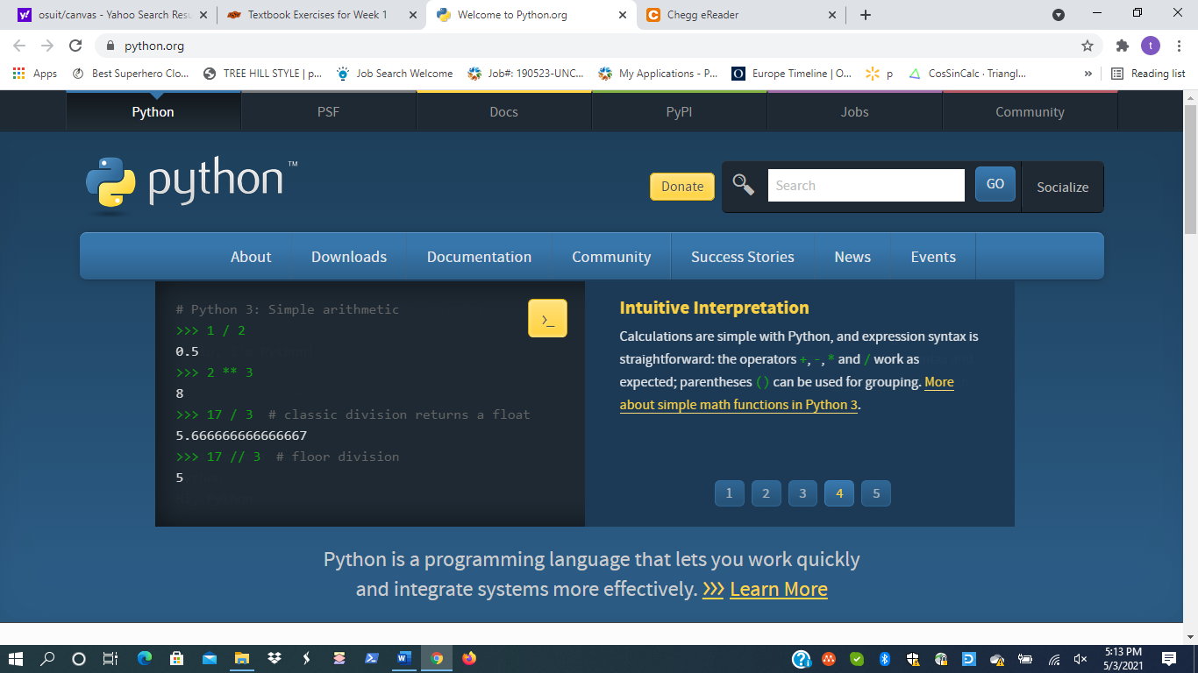

2.

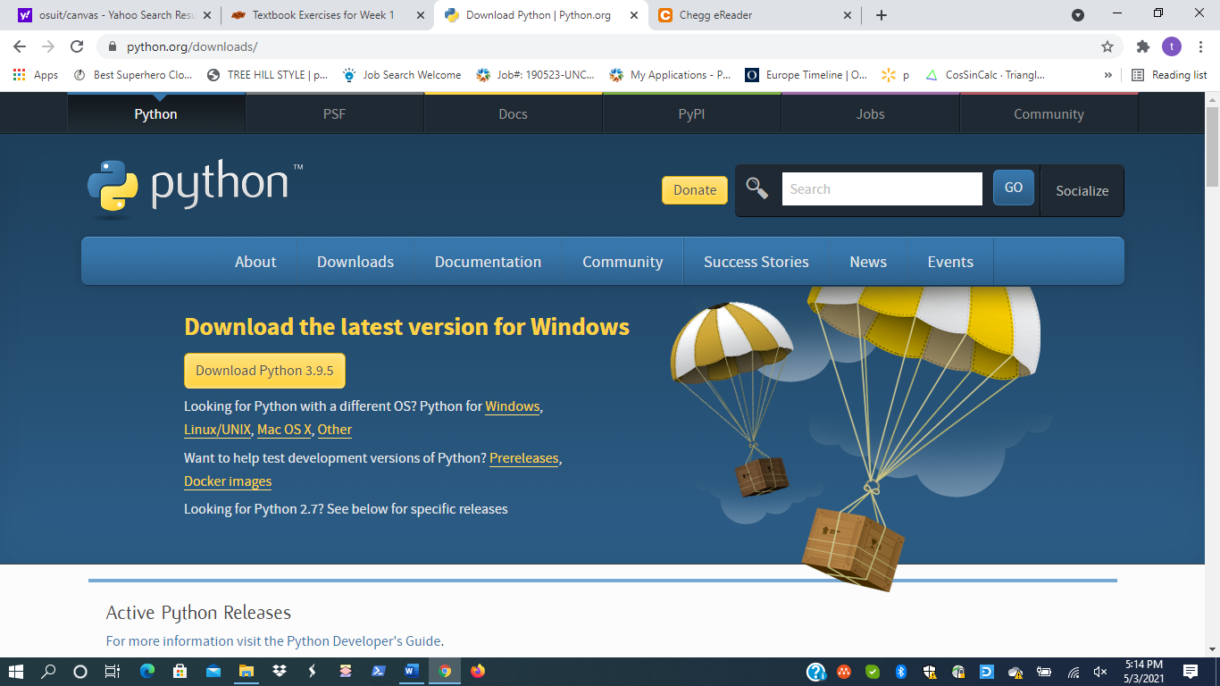

3.

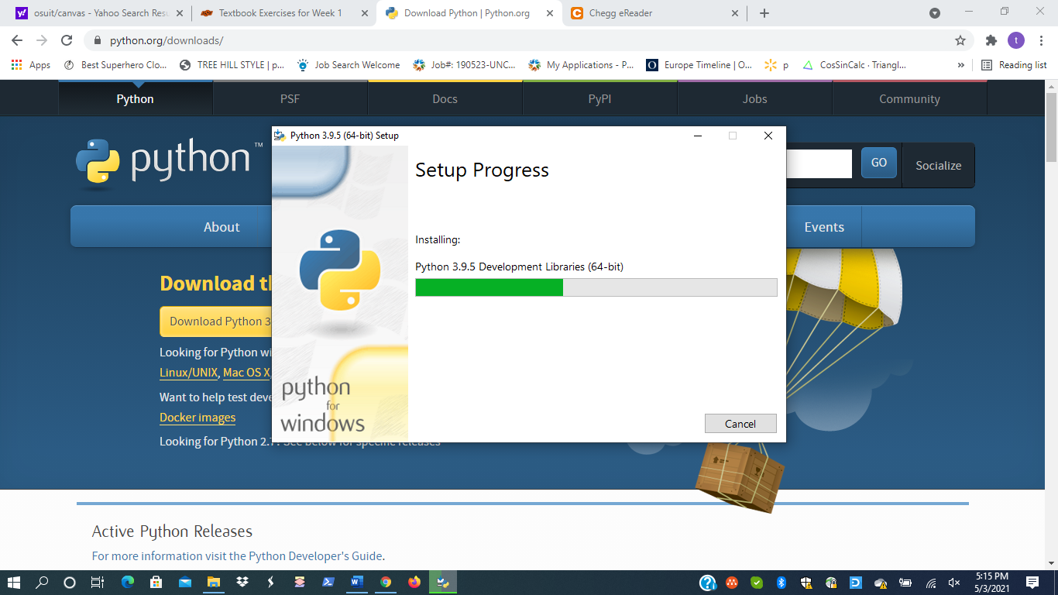

4.

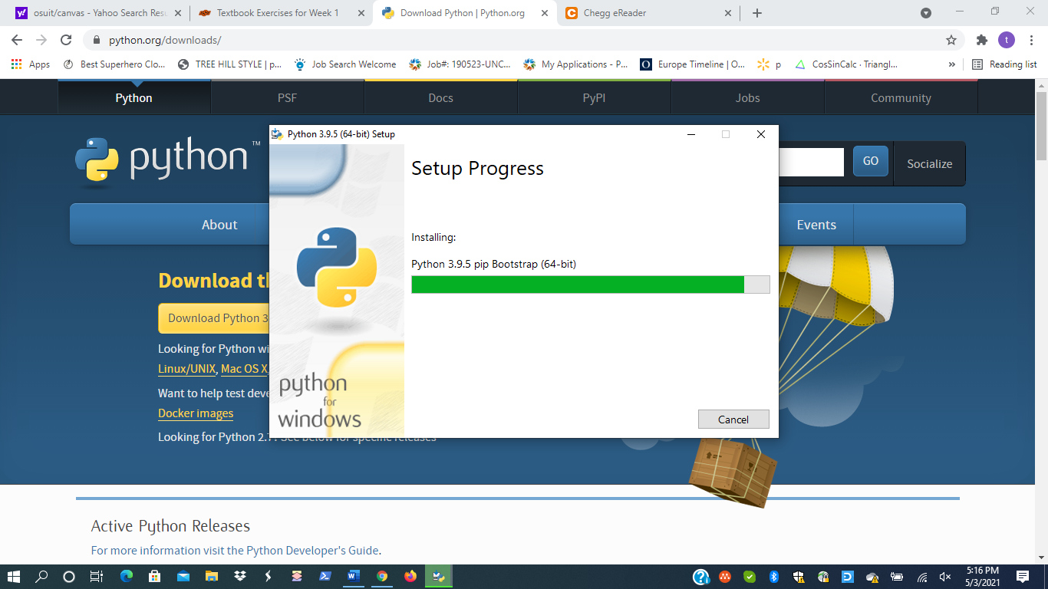

5.

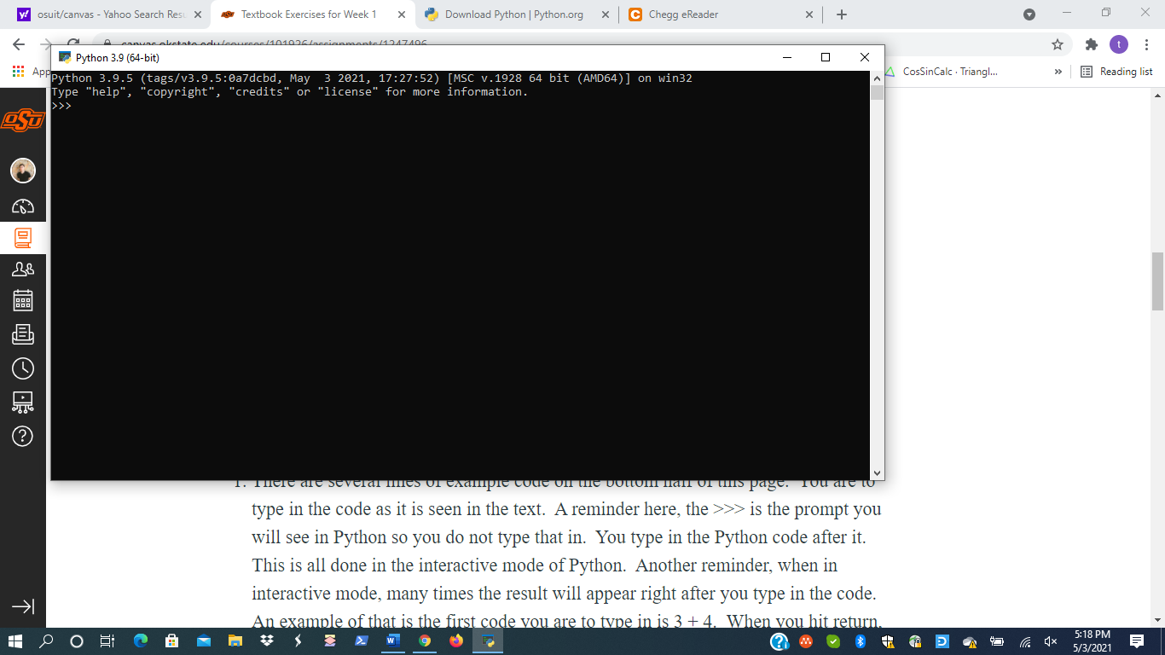

Page – 23

1.

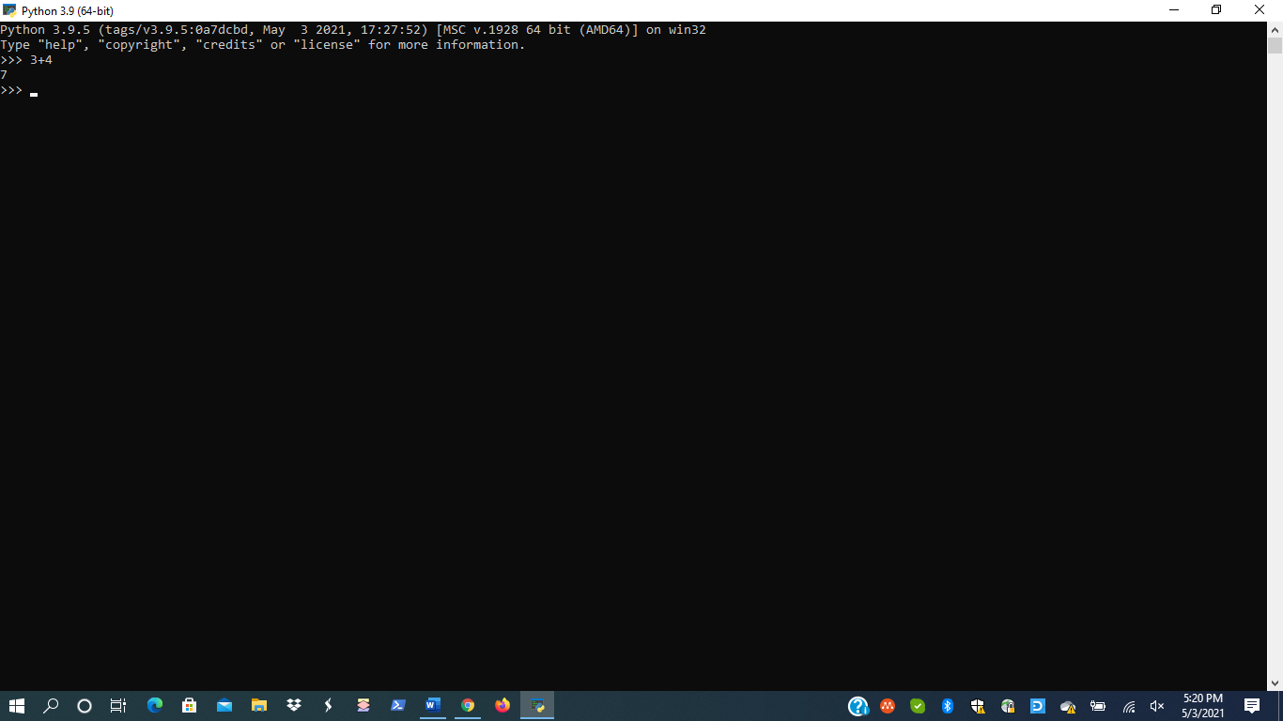

2. and 3.

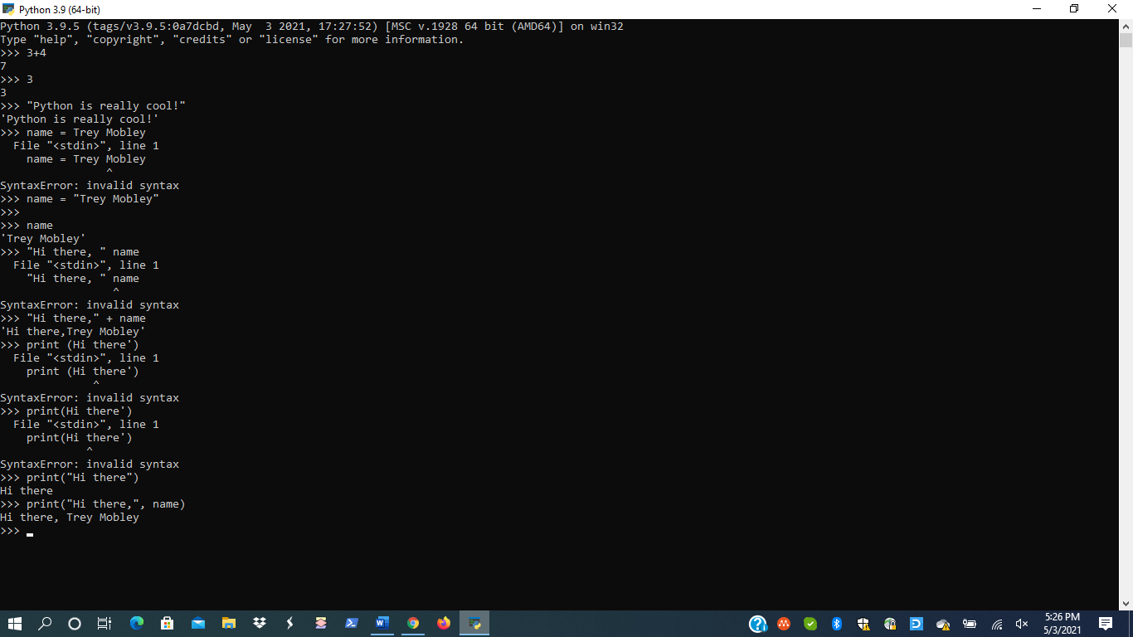

Page 25

1., 2., 3.

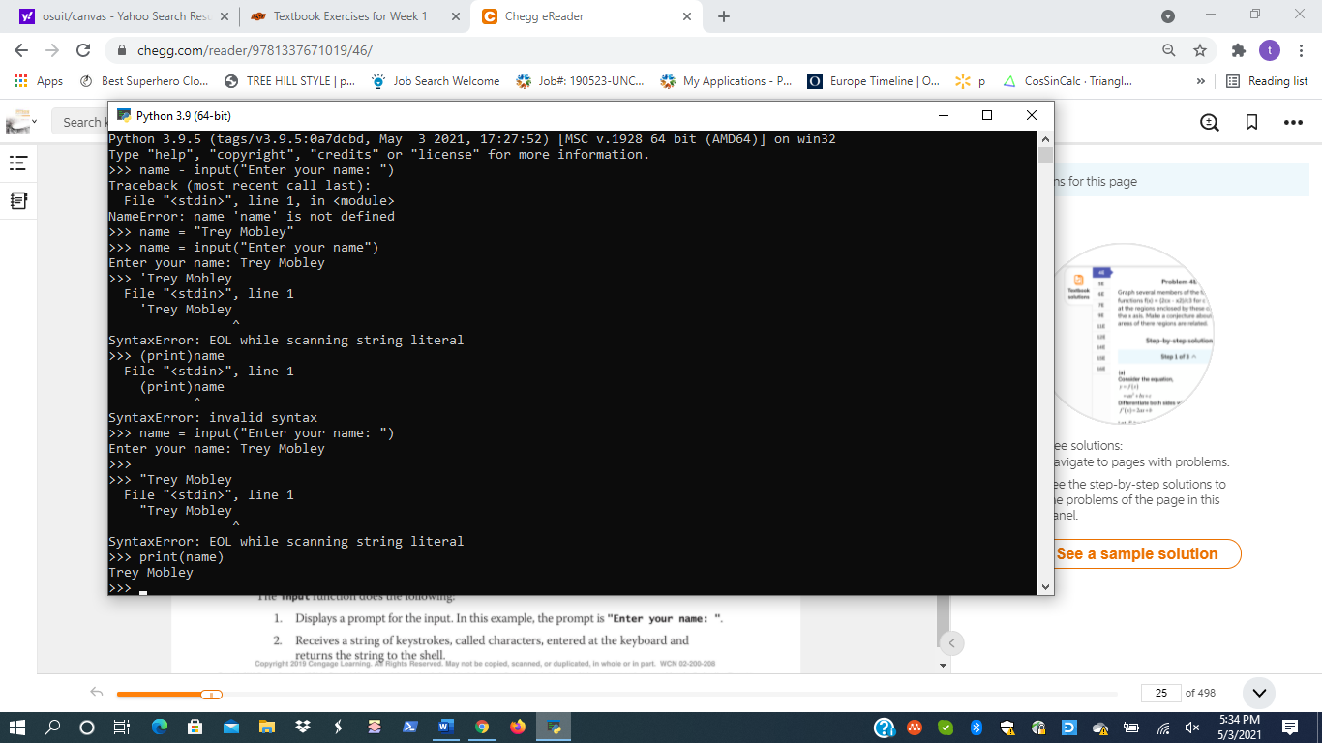

Page 26

1.,2.,3.

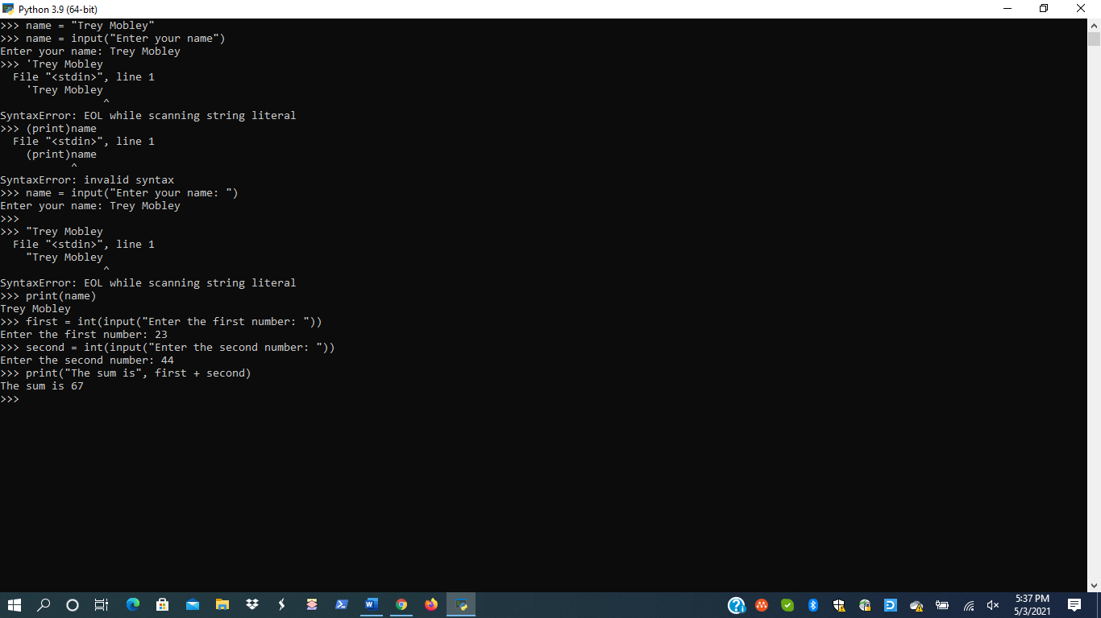

Page 29

1.,2.,3.,4.

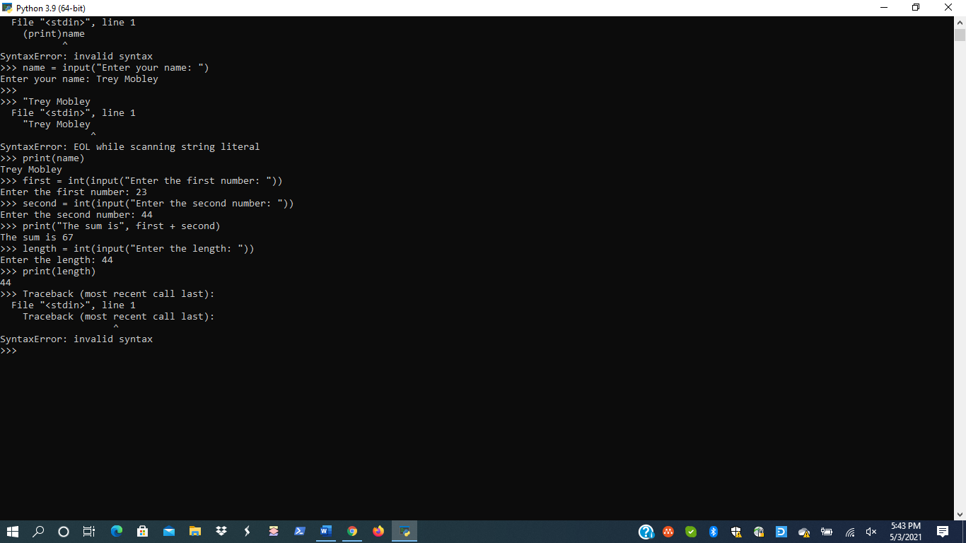

Page 30

1.,2.

